Title of the Manuscript
First Author¹, Second Author², Third Author³,…………….
¹Affiliation, Department, University, City, Country
²Affiliation, Department, University, City, Country
³Affiliation, Department, University, City, Country
………………………..
Corresponding author: email@example.com

Abstract
This document serves as a template for authors preparing manuscripts for submission to the Algerian Journal of Electrical Systems and Sustainability (AJESS). The abstract should provide a concise summary of the work, including the main objectives, methods, results, and conclusions. It should not exceed 250 words.

Keywords
Keyword1; Keyword2; Keyword3; Keyword4; Keyword5

1. Introduction
The introduction should establish the context, motivation, and scope of the research. Authors are encouraged to:
- Clearly identify the research problem or gapthat the paper addresses.
- Provide an adequate backgroundand technical context for readers unfamiliar with the subject.
- Include a comprehensive and recent literature review, citing relevant studies and highlighting their contributions and limitations.
- Emphasize why the chosen method, material, or technology is preferred over alternatives, supported by comparative analysis where applicable.
- Explicitly state the objective(s)and significance of the work.
- Conclude the introduction with a clear outline of the paper’s structure (e.g., "Section 2 presents..., Section 3 discusses..., etc.").

2. Materials and Methods
2.1. Page Format
Your paper should use a page size suitable to A4 format paper. The margins are set as follows: top= 2.5 cm, bottom= 1.5 cm, right=1.2 cm, left = 1.5 cm.
2;2. Text Font
The entire document should be prepared in Times New Roman font size 10 pt. Paper title should be regular font size 22pt, centered, bold, and not all with upper case. Author names should be centered, regular font size 12 pt. Affiliations should be regular font size 8 pt and italic. Email address of corresponding author should be centered, font size 9 pt. More than 3 levels of headings should not be used. Level 1headings should be left-justified, bold, numbered using Arabic numerals, regular font size 10 pt. The all letter of each title capitalized. Level 2, 3 and more headings should be left-justified, italic, numbered using Arabic numerals, regular font size 10 pt. The first letters of each title word capitalized and then lowercased. A line should be given before each title.
2.3. Equations and Units
Equations should be centered with equation numbers set flush right as in Equation (1). Formatting for MathType, use the Times + Symbol 11. Use either SI (MKS) or CGS as primary units. As a common mistake, please use (arb. uni.) for abbreviation of “arbitrary units”, not use (a.u.) because of the “atomic unit”.
$φ_{\text{b0}}=\frac{\text{kT}}{q}\text{ln}\left(\frac{\text{AA}T^{2}}{I_{0}}\right)$ (1)
2.4. Tables
For table title, table head, and table text should be provided. Tables and figures can be placed on separate pages at the back of the manuscript if it is necessary. Table body should be centered and in 10pt Regular font.
Table1.Publication number in 2025 as an example.
Date | Publications (in 2020)
Date | Articles | Journals | Books
1. Half | 1250 | 3 | 1
2. Half | 876 | 4 | 1
3. Half | 843 | 8 | 2
4. Half | 775 | 9 | 3
2.5. Figures
One Figure or Graph, each with a title, can be placed apart from the article text in the separate page if it is necessary. Figures should be numbered using Arabic numerals in the text. Figures grouped together should have similar dimensions and be labeled "a, b, c", etc. The colorful and black-white images should be imported at a minimum of 300 dots per inch (dpi). Examples; ....in Figure 1, Figure 2(a) shows….., ….from Figure 2(a-c).
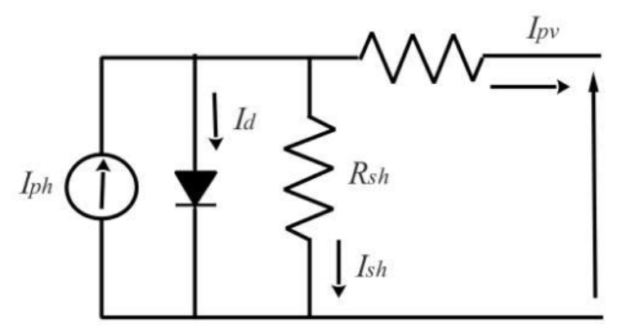
Fig. 1. An example figure for preparing manuscript
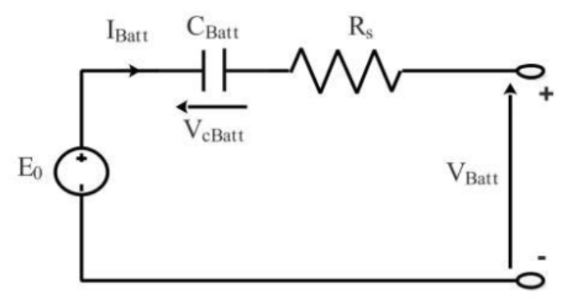
(a)
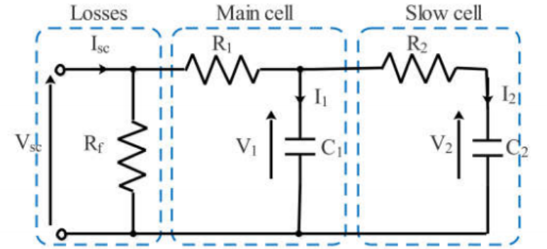
(b)
Fig. 2. Figure example, (a) Abcx, (b) Xyza
2.6. Figure Captions
Figures should be numbered using Arabic numerals. Figure captions should be in 10 pt. Figure captions should be centered below the related figure. A caption should comprise a brief title.
2.7. Table captions
Table heads should appear above the tables and tables should be numbered using Arabic numerals. Table title should be centered and in 10 pt. Captions with table numbers should be placed above the related tables, as shown in Table 1.

3. Results and Discussion
Please provide the different obtained results clearly and concisely, supported by relevant tables, figures, and numerical data where appropriate. Discuss the significance of the results with respect to the objectives of your study. Compare your findings with those from previous work, and explain any similarities, differences, or unexpected outcomes. Ensure that each result is critically interpreted.

4. Conclusion
Please provide a concise summary of the key findings and their significance. The conclusion should emphasize the potential implications of your study for research, policy, or practical applications. While it may briefly revisit the main outcomes, do not replicate the abstract or other sections of the manuscript. Instead, highlight the added value of the study, possible limitations, and future research directions if applicable. A strong conclusion strengthens the overall impact and clarity of the work.
Appendix
Appendixes, if needed, appear before the acknowledgment. Please not use number for the heading of this section.

Acknowledgements
Write the content of this section here...

References
References must be written in font size of 10 pt and IEEE style basis. For more details, please check the previous publications.
Conference Paper in proceedings;
[#] A. Author of Paper and B. Author of Paper, "Title of paper," in Title of Published Proceedings: Proceedings of the Title of Conf.: Subtitle of conference, Month Date, Year, Location, A. Editor and B. Editor, Eds. Place of publication: Publisher, Year. pp. inclusive page numbers.
[1]L. Liu and H. Miao, "A specification based approach to testing polymorphic attributes," in Formal Methods and Software Engineering: Proc.of the 6th Int. Conf. on Formal Engineering Methods, ICFEM 2004, Seattle, WA, USA, November 8-12, 2004, J. Davies, W. Schulte, M. Barnett, Eds. Berlin: Springer, 2004. pp. 306-19.
Conference Paper from internet;
[#] A. Author of Paper and B. Author of Paper, "Title of paper," in Proceedings of the Title of Conf.: Subtitle of conference, Month Date, Year, Location [Format]. Place of publication: Publisher, Year. Available: Database Name (if appropriate), internet address. [Accessed: date of access].
[3] J. Lach, "SBFS: Steganography based file system," in Proc. of the 2008 1st Int. Conf. on Information Technology, IT 2008, 19-21 May 2008, Gdansk, Poland [Online]. Available: IEEE Xplore, http://www.ieee.org. [Accessed: 10 Sept. 2010].
Journal;
[#] A. A. Author of article. "Title of article," Title of Journal, vol. #, no. #, pp. page number/s, Month year.
[3]J. R. Beveridge and E. M. Riseman, "How easy is matching 2D line models using local search?" IEEE Transactions on Pattern Analysis and Machine Intelligence, vol. 19, pp. 564-579, June 1997.
[4] K. Kakouche, A. Oubelaid, S. Mezani, D. Rekioua, T. Rekioua, “Different control techniques of permanent magnet synchronous motor with fuzzy logic for electric vehicles: analysis, modelling, and comparison”, Energies, vol. 16, no.7, 3116, pp.1-28, Marsh 2023.

Thesis;
[#] A. A. Author, "Title of thesis: Subtitle," Unpublished thesis type, Abbrev, Dept., Abbrev. Univ., Location of University, Abbrev. State, Country, Year.
[5]M. W. Dixon, "Application of neural networks to solve the routing problem in communication networks," Ph.D. dissertation, Murdoch Univ., Murdoch, WA, Australia, 1999.
Book;
Authored; [#] A. Author, Title: Subtitle (in italics), Edition(if not the first), Vol.(if a multivolume work). Place of publication: Publisher, Year, page number(s) (if appropriate).
[6] D. Rekioua, E. Matagne, Optimization of photovoltaic power systems, Modelization, Simulation and Control, Series: Green Energy and Technology. Edition Springer, 2012.

Edited; [#] A. A. Editor, Title: Subtitle (in italics), Edition(if not the first), Vol.(if a multivolume work). Place of publication: Publisher, Year, page number(s) (if appropriate).
[7] D. Sarunyagate, Ed., Lasers. New York: McGraw-Hill, 1996. (Editör)
Internet documents;
[#]A. Author, "Document title," Webpage name, Source/production information, Date of internet publication. [Format]. Available: internet addrs. [Accessed: Date of access].
[8]J. Eralds, "Electromechanical system,", Jan. 31, 2001. [Online]. Available:http://www.motiongenesis.com/ [Accessed: Sept. 12, 2004].

Formatting Notes
- Use Times New Roman font, size 10 pt.
- Line spacing: Single.
- Page size: A4 with 2.5 cm margins.
- Equations should be numbered and formatted using Equation Editor.
- Figures and tables should have captions and be cited in the text.

